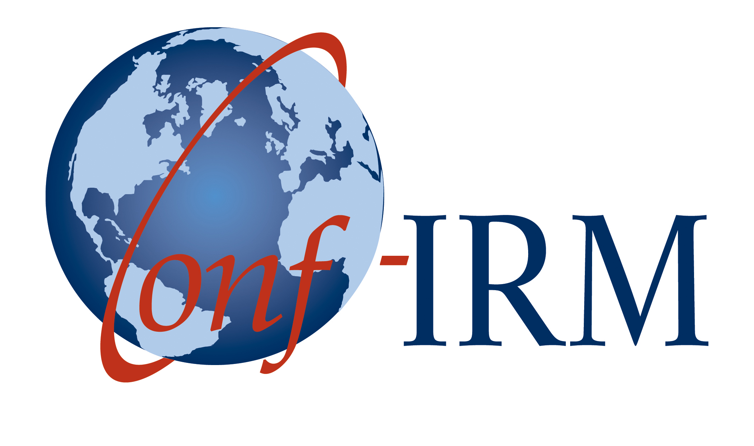
2016 International Conference on
Information Resources Management


An AIS Affiliated Conference
Call for Papers
Conference Theme: Digital Emancipation in a Networked Society
Track 02: Enterprise Systems and Knowledge Management
May 18-20, 2016
The Waterfront - Cape Town, South Africa
Track chairs
Nelly Todorova - University of Canterbury, New Zealand nelly.todorova@canterbury.ac.nz
Ojelanki Ngwenyama - University of Cape Town, South Africa o.ngwenyama@uct.ac.za

Important dates
Submission deadline: January 10, 2016
Notification of submission decision: February 21, 2016
Final submission due date for accepted papers: March 16, 2016
Early registration deadline: March 23, 2016
Submission
Full-research, research-in-progress, teaching cases and proposals for panels and tutorials to Conf-IRM 2016 are to be submitted via www.conf-irm.org. All submissions will be double-blind peer-reviewed and handled by the track chairs.
Track coverage
Enterprise Systems and Knowledge Management solutions when introduced into an organization require organizational and often cultural change. To be effective these solutions must be managed, tailored, deployed and used in ways that enhance business processes and practices and lead to improvements in innovation, and organizational performance. Building on existing work in knowledge management (KM) and enterprise systems (ES) this track promotes an interdisciplinary approach that examines the technical, managerial, behavioral, and social issues that arise in organizations in relation to the design, deployment, use and impact of ES and KM systems.
Recommended topics
Topics of interest may include, but are not limited to, the following:
- Knowledge creation and sharing in organizations | - Inter-organizational impacts of ES
- KM and organizational learning | - Emerging and future trends in KM and ES
- ES in tertiary education | - KM and ES with social media
- KM and ES for organizational transformation | - Integrating KM and ES
- Managerial, social and behavioral issues in KM and ES | - ES and business process management
- KM and ES governance, strategy and performance | - ES and mobile enterprise applications
- Development, use, diffusion and impact of KM and ES | - New ES architectures
- Managing the full ES lifecycle | - Knowledge creation and sharing in organizations
Submission Types and Guidelines
Full length submissions
Submissions must be no more than 12 pages, including references, appendices and title page. All submissions must follow the submission template specifications. Submissions must be original and previously unpublished, conceptual or empirical research manuscripts. Papers that are highly rated by the reviewers will be considered for publications in selected journals. The paper that best represents, in terms of quality and suitability, the theme and ideals of the conference will be awarded the "Best Paper Award" during the conference.
Research-in-progress submissions
Submissions must be no more than 7 pages. All research-in-progress submissions will be published in the proceedings as short papers.
Teaching cases
We welcome submissions of teaching cases. The cases should be based on real situations and targeted at specific learning objectives. Cases should be no more than 12 pages and must be accompanied by instructor teaching notes (not included in the 12 pages). The teaching notes will not be published.
Workshop, panel and tutorial submissions
Submissions must be no more than 3 pages. Proposals should include the objectives, topics to be covered and the full details of all presenters. Method of presentation is at the submitter's discretion; however, the submitter has the responsibility for providing his/her own panel members. All accepted proposals will appear in the conference proceedings.
Important announcements
- The number of submissions by an author (including joint authorship) is strictly limited to a maximum of two.
- Authors of accepted papers (at least one person per submission) and all panel members and tutorial presenters MUST register AND attend the conference.
- Submissions of ALL TYPES must be received by the above deadlines.
- While the primary language of the conferences is English, papers in French will also be accepted. The ICT in Latin America and the Caribbean, and the ICT initiatives in the African context tracks will accept papers in French, Portuguese and Spanish, as well as English.
- Accepted papers will be published in the conference proceedings in their entirety upon payment of registration fees. Papers accepted and presented at the conference will also be placed in the AIS e-Library. Papers not presented at the conference, for any reason, will not be included in the AIS e-Library.
Organizing committee
Conference Co-Chairs
Felix Tan, Auckland University of Technology, New Zealand  felix.tan@aut.ac.nz | Irwin Brown, University of Cape Town, South Africa  Irwin.brown@uct.ac.za
Program Co-Chairs
Lisa Seymour, University of Cape Town, South Africa  Lisa.seymour@uct.ac.za | Antonio Díaz Andrade, Auckland University of Technology, New Zealand  antonio.diaz@aut.ac.nz
Publications and Proceedings Co-Chair
Lech Janczewski, The University of Auckland, New Zealand lech@auckland.ac.nz
Conf-IRM Executive Committee
Gerald Grant, Carleton University, Canada (co-chair)  Jairo Gutierrez, AUT University, New Zealand  G. Harindranath, Royal Holloway, University of London, UK | Lech Janczewski, University of Auckland, New Zealand  Sherif Kamel, The American University in Cairo, Egypt  Felix B. Tan, AUT University, New Zealand (co-chair)
We look forward to your submissions and seeing you in Cape Town, South Africa in May 2016!

